STEINBRENNER PTSA NEWSLETTER
JANUARY/FEBRUARY 2023
VOLUME 10
ISSUE 5

George Steinbrenner High School 5575 W. Lutz Lake Fern Rd.
Lutz, Florida 33558
813.792.5131
A Hillsborough County School

Visit our website: steinbrennerptsa.com
Calendar
January:
27 High School Report Cards released
February:
3 3:00pm-PTSA Senior Scholarship Application Deadline (pg. 3)
9 6:00pm-World of a Teen; Online-CLICK HERE for login information. (pg. 1)
13 Conference Night
13 6pm-Juniors Parent Night; Steinbrenner Auditorium
17 Non-Student Day-No School
17 Rank Freeze for Seniors
March:
1 Juniors take SAT during school day hours
6 Non-Student Day-No School
7 Senior Sunset-time TBA
13-17 Spring Break-No School
24 End of 3rd Grading Period

*Dates and times are subject to change
PTSA Calendar Steinbrenner HS Calendar District Calendar

1
www.steinbrennerptsa.com

2022-2023 Board Members
Steinbrenner PTSA Need YOU!
Our PTSA is looking for volunteers to fill vacancies for the 2023- 2024 school year. Join our dedicated and fun group of volunteers and stay connected to Steinbrenner. Any level of commitment is welcome, and we have opportunities for anyone who would like to be involved.
If you are interested or have questions, please contact Alison Newman at gshsptsapresident@gmail.com.
President: Alison Newman
Treasurer: Natasha Sherwood 1st VP Membership: Tamara Ponce
2nd VP Strategic Planning: Hanna Curry 3rd VP Fundraising: Shelly Saunders
4th VP Volunteers: Venessa Daughtrey Recording/Corresponding Secretary:
Shadia Aouadi
ACT/SAT Prep and College Readiness Programs: Maurine Wheeler

Help us reach our budgeted goal so we can continue to support Teacher Grants, Senior Scholarships, Campus Beautification, and so much more.
JOIN ONLINE BY CLICKING HERE.
Questions: Email gshsptsamembership@gmail.com
Save money! Businesses offer discounts to PTA members. CLICK HERE to see how you can take advantage.
Hospitality: Laurie Grantham PE/Hope Uniforms and Spirit Wear:
Portia Engman
Senior Banners: Natali Lima Senior Events: Marty Sheehan
Lisa Aiken Steinbrenner Cares: Erica Rude
Teacher Appreciation Week:
Melissa Siebels Monica Young
Teacher Grants and School Improvements: Jennifer Harbour
ORDER YOUR SENIOR BANNER
Do not miss out on honoring your SENIOR! Order a senior banner today.
CLICK HERE to order:
- $40 for small
- $75 for large
The banners will hang in the hallways of the school and cafeteria during 4th quarter 2023. All banners will be returned at Senior Send Off. You can then show your pride and display the banner at home.
If you are considering the purchase of a banner but are not sure what picture to use or your quote, place the order anyway. We will follow up with you for the information needed before the banner goes into production. Just fill out as much as you can on the form and make your payment.
Email high resolution photos and quotes to
gshsptsaseniorbanners@gmail.com
DEADLINE TO ORDER A BANNER, AND SUBMIT YOUR PICTURE AND QUOTE IS MARCH 10, 2023.
Feel free to contact us with any questions
gshsseniorbanners@gmail.com.
Website and Social Media:
Michelle St. John Dawn Hoskins
World of a Teen: Francine Phillips
Jennifer Labadie-Waldhauser
Awards: Cheryl Michel
Newsletter: Leslie Nixon
Reflections: Melissa Siebels School of Excellence: Amy Pardo Senior Scholarships: Kristen Miller
Bethany Mis Faculty Representative: Heather Prokop Member at Large: Jonilyn Maglott
Monica Young
Principal: Tiffany Ewell

2
STAY IN THE KNOW
Steinbrenner PTSA
Website:
www.steinbrennerptsa.org
The PTSA website can be translated into a variety of languages. Scroll to the bottom of the home page and click on “Select Language.” From there, choose your preferred language.
Steinbrenner
PTSA
online
store:
https://gshsptsa.memberhub.store/
PTSA Newsletter: The Steinbrenner PTSA newsletter will be sent monthly to all registered families. shsptsanews@gmail.com
Steinbrenner PTSA Facebook: Join the Steinbrenner PTSA Facebook page for the latest school news. https://www.facebook.com/steinbrennerptsa/
PTSA Twitter: https://twitter.com/SteinbrennerPTA School News: Steinbrenner High School website
http://steinbrenner.mysdhc.org/
District News: Hillsborough County School District Website https://www.hillsboroughschools.org
Hillsborough County PTA
Florida PTA
National PTA
Canvas
CLASS OF 2024
PTSA Senior Scholarship Volunteer Opportunities
Save the dates! More information will be posted on social media. Times TBA.
February 14:
March 7:
April 11:
6:30am-Valentines for Teachers
Senior Sunset
Senior
Awards-Honors
Graduate
Event setup (evening)
April 12: Senior Awards-invite only, Student and Family Event (evening)
April 24: Hanging Senior Banners-after school
May 15: Take down Senior Banners-after school
May 18: Senior Send Off
Email to sign up: gshsptsavolunteers@gmail.com
Want Volunteer Hours Toward the Bright Futures Scholarship?
Submit an article and at least one picture to the PTSA Newsletter and start earning required volunteer hours toward the Bright Futures Scholarship.
- Article can be about anything school/education related or a topic that is important to you and others your age.
- Must include at least one picture. Student is not required to be in the picture.
Deadline to submit an article for the next newsletter is February 19. Submitted articles must be well written, are subject to editing, and will be forwarded to Ms. Ewell for approval prior to publishing.
Submit your article, picture(s), and/or questions to Leslie Nixon at shsptsanews@gmail.com.
Steinbrenner PTSA Senior Scholarship
APPLICATION DEADLINE: 3:00pm FEBRUARY 3, 2023
Do not forget! To qualify, students must:
- Be a graduating senior from Steinbrenner High School.
- Be a member of Steinbrenner PTSA as of December 31, 2022.
- Have a minimum weighted 3.0 GPA.
- Obtain 5 PTSA approved volunteer hours.
*For the class of 2023, we are allowing 5 Steinbrenner related volunteer hours.
- Submit an essay, completed application, and 2 teacher recommendations.
The completed application with essay and teacher recommendations must be dropped off to the PTSA mailbox at the front office no later than 3:00pm February 3, 2023. CLICK HERE for additional information.
Contact our PTSA Volunteer Coordinator at gshsptsavolunteers@gmail.com to find out about upcoming volunteer opportunities. Opportunities will also be posted on our social media accounts: Facebook @steinbrennerptsa, Twitter @steinbrennerpta, Instagram @gshsptsa.
CLICK HERE to purchase your PTSA membership.
**The number of scholarships awarded, and dollar amount of each scholarship is determined by the PTSA budget.**
Questions? Email gshsptsascholarship@gmail.com

All applicants must be current members of a Hillsborough PTSA and must be graduating from a Hillsborough County high school in 2023. Deadline for submission is March 12, 2023, 11:59pm EST.
CLICK HERE to apply.
Scholarship recipients will be selected based on a combination of merit and financial need, with preference for students involved in their PTSA. Scholarship winners will be notified by May 1, 2023. Scholarships will be awarded at the HCC PTA/PTSA awards banquet held on May 20, 2023.

All applicants must be current members of a Hillsborough PTSA and must be graduating from a Hillsborough County high school in 2023. Deadline for submission is March 12, 2023, 11:59pm EST.
CLICK HERE to apply.
Scholarship recipients will be notified by May 1, 2023. Scholarships will be awarded at the HCC PTA/PTSA awards banquet held on May 20, 2023.
ALL VOLUNTEERS:
Want to volunteer at Steinbrenner? CLICK HERE to select the volunteer opportunities that interest you.
If you have not filled out the district’s volunteer application, do so by CLICKING HERE. All volunteers are required to have an approved application on file.

Scholarships available for Hillsborough County High School Seniors.
- 90 named scholarships available
- Nearly 200 scholarships awarded
- $500-$15,000
Deadline: Tuesday, January 31, 2023
CLICK HERE for a list of available scholarships, criteria, and to apply.

Ugly Sweater Day

STEINBRENNER SPIRIT WEAR

Mascot Universe is the place to go for all your spirit wear needs! Their location, in the Publix plaza next to Rice and Roll, has lots of space for all the Steinbrenner spirit wear. Shop there for several of our new designs.
Mascot Universe donates back to our PTSA for every Steinbrenner item purchased.
Cannot make it to the store? CLICK HERE to place an order.
BECOME A STEINBRENNER PTSA BUSINESS PARTNER
We are currently looking for businesses in our community and corporate sponsors to help our school succeed this school year. With your partnership, we will be able to continue offering support to our students and teachers.

- Donations of funds, products, and/or services are tax deductible.
- Business Partners will be featured on the PTSA website and in our newsletter that is
published to
families.
over
2000 Steinbrenner
If your business would like to partner with
Steinbrenner PTSA and help us provide additional opportunities for our students, teachers, and staff, please contact us at gshsptsasponsors@gmail.com.
We Want to Hear from YOU
Steinbrenner PTSA is looking for input from our GSHS teachers, parents, and students for new ideas to make our PTSA more meaningful to our Warrior Community. If you have an idea for a new program or something you would like to see from the PTSA, we would love to hear it!
Please
email
Hanna
Curry
at
gshsptsastrategicplanning@gmail.com with subject
line “New Idea.”
Georgia
Georgia is the Agriculture and Veterinary Assistant room mascot. She is a senior rescue dog who keeps an eye on the students. Here she is making sure everyone is studying hard.

THANK YOU FOR YOUR DONATION
SUPPORT THE BUSINESSES THAT SUPPORT OUR PTSA & SCHOOL COMMUNITY.
An appointment is not needed, but feel free to check out their website www.lutzuc.com and fill out the patient registration form to speed up the process.
Most major insurances accepted.

THANK YOU FOR YOUR DONATION
#1 community bank in Florida and top 100 nationwide by American Banker.
Invest in your community when you open a checking account with First Citrus Bank.
Visit their website www.firstcitrus.com for more information. First Citrus Bank can help you with all your personal and business banking needs.

CONGRATULATIONS REFLECTIONS PARTICIPANTS!
2023 Teacher Appreciation Week May 1-5
Teacher Appreciation Week is quickly approaching, and we need your help!
Our teachers and staff are dedicated to our children’s education and well-being. We want to show them how much we appreciate everything they do.
We need donations from local businesses to use as teacher gifts. Donations to Steinbrenner PTSA are:
- Tax deductible.
- Acknowledged and thanked in the Steinbrenner PTSA Newsletter that is sent out to all registered parents.
- Acknowledged and thanked on social media.
Monetary donations are also accepted through our online store. Donate by CLICKING HERE.
If you are interested in donating, please contact Melissa Siebels at gshsptsastaffappreciation@gmail.com.
Additional information about Teacher Appreciation Week is coming soon!
The following students participated in the National PTA Reflections Art Program. Their art advanced from the local level competition to the county level.
Literature:
1st Dana Kingery
2nd Jackson Behuniak 3rd Isabella Barfield
Music Composition:
1st Connor Wood
2nd Leanne Agraviador 3rd Drew Tomasiello
Dance Choreography:
1st Alyssa Hayman Visual Arts:
1st Ariane Hale
Photography:
1st Alyssa Hayman
Their artwork competed against others from the Hillsborough County area.

STATE LEVEL ADVANCEMENT!
The following students’ art advanced from the Hillsborough County competition to the State of Florida competition:
Student Leadership Advisory Council
The PTSA Student Leadership Advisory Council had its first meeting on January 9, 2023. The 17 members are eager to start making improvements, increase student engagement, and let their voices be heard. With representation from all grades, the group represents a wide range of students.
During the first meeting, the Council discussed goals, projects, and ways to make Steinbrenner even better. The group discussed that leading means not just noticing areas for improvement but also coming up with plans to help make the improvements. From hallway décor to school event attendance to communication, the meeting was full of impactful ideas.
The Student Leadership Advisory Council is always welcoming new students to join. If interested, CLICK HERE and fill out the form. Once we receive your information, further instructions will be provided. We are excited to take on our first project in February. Make sure you read the March edition of the PTSA Newsletter for an update about this exciting project.
Alyssa Hayman-Photography
Leanne Agraviador-Music Composition Drew Tomasiello-Music Composition Alyssa Hayman-Dance Choreography
WE ARE PROUD OF ALL OUR STEINBRENNER STUDENTS WHO SUBMITTED THEIR AMAZING ENTRIES!
STEINBRENNER CARES
Thanks to your generous donations, Steinbrenner Cares was able to provide 14 Holiday Food Baskets to families in need.
A big thank you goes to Mascot Universe for partnering with us and providing Steinbrenner gear for holiday gifts and to Mr. Strickland for coordinating all the deliveries.

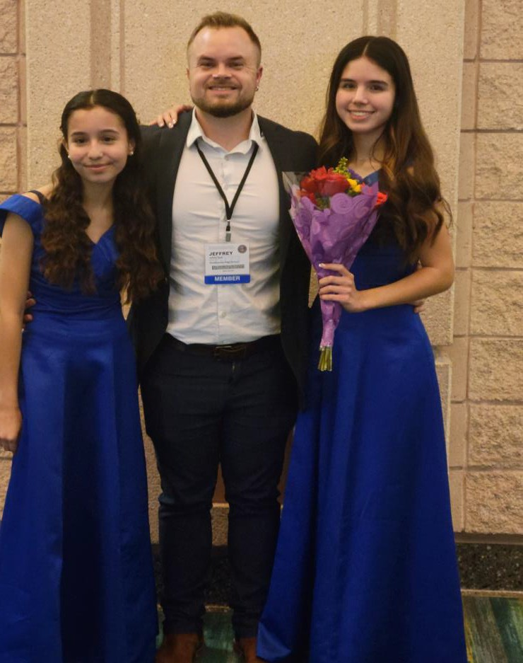

National PTA: Healthy Minds
Making small changes as a family today can make a big difference for everyone’s mental health and well- being tomorrow. It can be hard to know where to start, but National PTA’s Healthy Minds Family Action Plan can help you commit to actions that will support your family’s well-being.
Go to https://bit.ly/3X5yeUe for more information.

Registration is open for National PTA’s 2023 Virtual Legislative Conference (LegCon). LegCon is a great opportunity to learn how to make an impact on policy decisions at the local, state, and national level and raise your voice with your members of Congress on issues important to you and your community.
Register today! www.PTA.org/LegCon

A Podcast for Parents, by Parents
PTA is working to ensure our public schools provide a high-quality education for every child to reach their full potential. Notes from the Backpack is a PTA podcast designed for millions of parents and the decisionmakers they influence.
Through the unique combination of expert, parent, and educator guests, each episode features engaging conversations that offer real life advice and ideas on how to support children’s learning and development.
Real Experts. Real Parents.
Real Conversations.

All State Chorus, January 13

Holiday Cheer Practice

ORCHESTRA
Steinbrenner Orchestra members are preparing for FMEA and the Hillsborough All County Orchestra Concert.
Congratulations to the following students who auditioned and were selected to play in the Florida All State Ensembles:
9th-10th Grade Concert Orchestra
- Lucia Marti Garro
- Kaydence Rao
- Andy Wu
11th-12th Grade Symphonic Orchestra
- Colin LeBlanc
Congratulations to the following students who auditioned and were selected to play in the Hillsborough County All County Orchestras:

9th-10th Grade Orchestra
- Lucia Marti Garro
- Kaydence Rao
- Ankita Dekoule
- Kristina Galchenko
- Elain Roji
- Andy Wu
- Kaiden Schuster
- Evan McCormick
- Carl Arnold
11th-12th Orchestra
- Alex Cooks
- Caid Thackeray
- Eki Imudia Frias
- Ella Lawrence
- Connor O’Brien
- Colin LeBlanc

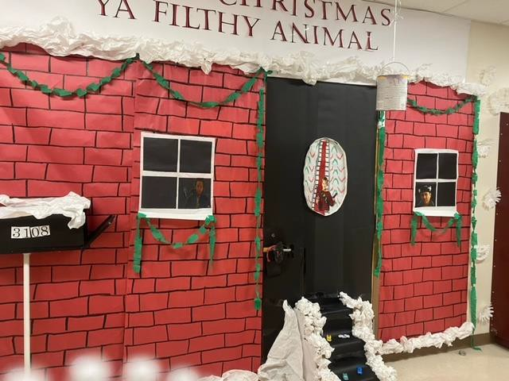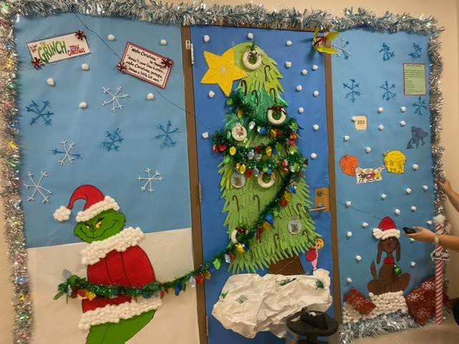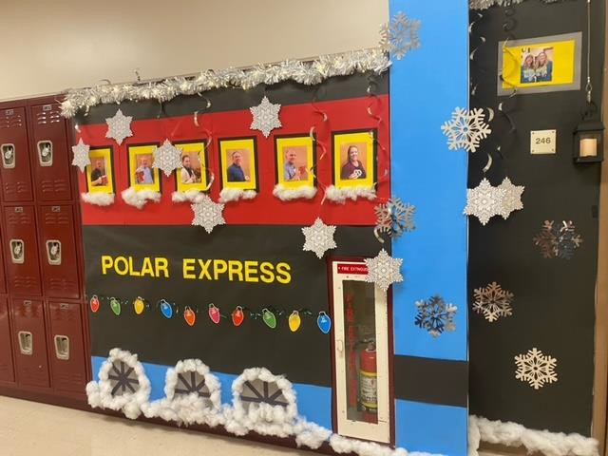
Door Decoration Contest Winners
Spirit Night-February 27, 11am-9pm at Panera Bread off SR-54 near the Suncoast Parkway. For us to get credit, you must tell them you are with the Steinbrenner High School Orchestra Booster Club.
Our college tour was rescheduled to February 1-4 due to Hurricane Nicole. Steinbrenner Orchestra will be on tour and performing with the orchestras of Jacksonville University and Florida State University. Students on this trip will be playing Mussorgsky and Copeland.
Support the Orchestra students at their Music Performance Assessment Pre-Concert held on February 21 at 6:30pm in the Steinbrenner High School Auditorium. Cost is $5.00 per person.
Steinbrenner Orchestra will be representing the state of Florida for the world premiere “The 50 State String Consortium” on April 28, 2023, at 6pm. American Composer Stephanie Ann Boyd wrote the piece. Our students will be working with this composer and 49 other orchestras. Thank you to Tom and Catty O’Brien for their generous donation facilitating our participation in this exciting event.

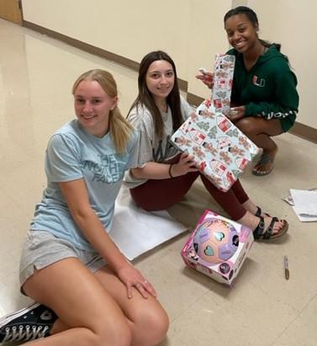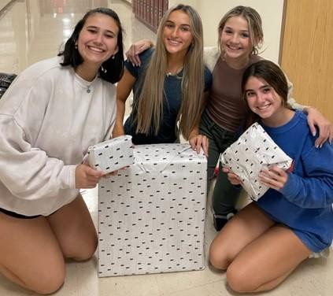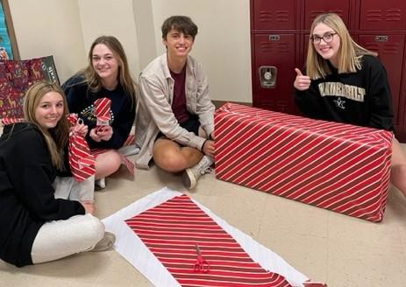
Beta Wrapped Gifts for Needy Children

HCC PTA/PTSA
According to the National Trafficking Hotline, it is clear there is a national crisis at hand. To end human trafficking, we must all become aware, educated, and engaged. Learn more by CLICKING HERE.
HCPS Energy powerED Program
Out of hundreds of submissions, Steinbrenner’s Brooke Snee placed 3rd in the Hillsborough County Public Schools Energy Logo Contest. Her creative interpretation of an energy program logo was submitted to HCPS and their partners at McKinstry Company poweED program for judging.
Congratulations Brooke Snee!
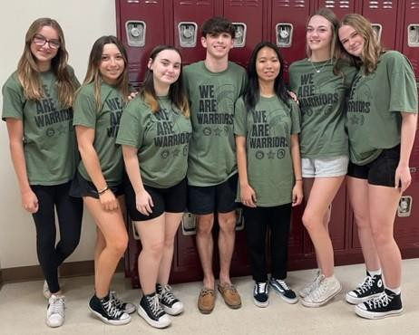

Transforming Family-School Partnerships with PTA’s
National Standards Webinar Series
National PTA’s Center for Family Engagement is partnering with the Institute for Educational Leadership for a five-part webinar series. The goal is to help district, school, and parent/community leaders explore our six National Standards for Family-School Partnerships through panel discussions with leading practitioners, researchers, and policy makers. Our hope is to improve family-school partnerships so that all children can reach their full potential.
All Webinars start at 2:00pm.
January 25-Webinar 1: Welcome All Families February 15-Webinar 2: Communicate Effectively March 1-Webinar 3: Support Student Success
March 29-Webinar 4: Speak Up for Every Child and Share Power April19-Webinar 5: Collaborate with Community
Register here: https://bit.ly/3k9gpF6

Supporting our Law Enforcement
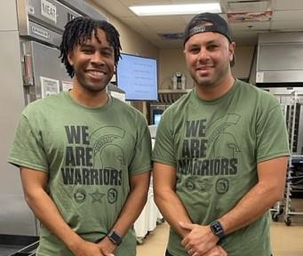

STUDENT SERVICES UPDATES
2nd Semester has Started
On January 10, students received a copy of their 2nd semester schedule and your student’s schedule may have changed. Since the first semester ended, if your student had a single semester course, a new class needed to be added for the 2nd Semester. To create a comprehensive schedule, several classes may have been rearranged. For some students, lunch periods were changed as well.
Schedule change requests are addressed for:
- Errors
- Student already completed and passed the class they are placed in
- Duplicate classes
Schedule change requests should not be submitted for:
- Lunch period change
- Class period preference
- Teacher preference
Motivate
A new semester brings a fresh start, and students are feeling motivated. We love their enthusiasm and want to keep the momentum going. Check in with your student often to make sure they are keeping up with homework, studying for tests, and checking canvas throughout the semester. The best way parents can assist their student is to monitor their grades and assignments on canvas. If your student has difficulty keeping up with assignments, they may want to use the reminder or calendar apps on their phone. If using their phone does not seem to do the trick, a physical planner may be helpful.
Programming
Counselors continue to meet with students during their English class to discuss their course choices for the 2023- 2024 school year. Each English class has been assigned a meeting day and your student will meet with their counselor on this day. If your student is absent on the assigned day or does not have an English class, a counselor will meet with them at a separate time. In this case, their counselor will reach out to them individually for a meeting.
March 10, 2023, is the deadline to make a schedule change request for the 2023-2024 school year. There will be NO EXCEPTIONS to this deadline. Directions to request changes are posted on canvas. Schedule change requests should only be submitted if a change is needed AFTER the meeting with their counselor. Otherwise, the change can be discussed during the in-person meeting on their assigned day. Most reasonable and approved requests for changes can be made.
The 2023-2024 class schedules will be created during the summer break. No group or person has priority over another.
Important Dates
January 27-Report cards are released
January 31-Deadline to complete the Hillsborough Education Foundation scholarship application. CLICK HERE to apply
February 6-10-Guidance Appreciation Week
February 13-Conference Night
February 13-6:00pm; Juniors Parent Night in the Steinbrenner Auditorium
February 17-Rank Freeze for seniors
March 1-SAT for juniors; during the school day
May 19-Deadline to submit dual enrollment paperwork to Hillsborough Community College (HCC)
July 14-Deadline to register for dual enrollment classes through HCC

STUDENT SERVICES UPDATES CONTINUED…

Dual Enrollment
Dual Enrollment courses are completed through Hillsborough Community College (HCC). Other than the authorization form B that Steinbrenner counselors must sign, everything else is conducted through HCC. Steinbrenner does not have access to HCC’s system, nor do we have any influence on decisions or deadlines they create.
Counselors have informed our students about their responsibilities and the impact of taking a dual enrollment course.
First, students MUST know the dual enrollment deadlines. The deadlines are posted on HCC’s website, on the Guidance Services Canvas page, and on the authorization form B. HCC is strict on their deadlines and if missed, your student will be unable to enroll or register for classes. On the other hand, if your student attempts to complete their enrollment requirements too far in advance, access to the required forms/information may be denied.
Second, enrollment and registration are completed through HCC’s website and your student’s Hawk email account. If your student is having technical issues, they need to contact HCC. Steinbrenner cannot help with dual enrollment technical issues. If your student is having trouble, do not procrastinate. As the registration deadlines approach, the HCC office become extremely busy, and it will be difficult to receive the technical support you need.
Third, it is the student’s responsibility to research the courses they want to take and know if they have any prerequisites such as, PERT, SAT, or ACT score requirements, etc. Students can be dropped from dual enrollment courses because they did not meet the specified requirements. In addition, a student should only sign up for the number of courses they can comfortably handle.
Finally, having an F or W (withdrawal) on a dual enrollment record does not look favorable for college admissions. Because a dual enrollment class is a college course, the grades earned will go on both the high school and college permanent records.
If your student is interested in earning their Associate of Arts while in high school, they need to schedule an appointment with an HCC advisor. Steinbrenner counselors do not advise students on college courses or degrees.
Scholarship Opportunities
National Society Daughters of the American Revolution (DAR) Scholarship
Deadline: January 31, 2023
CLICK HERE for more information and to apply.
TheDream.Us Scholarship
Deadline: February 28, 2023
CLICK HERE for more information and to apply.
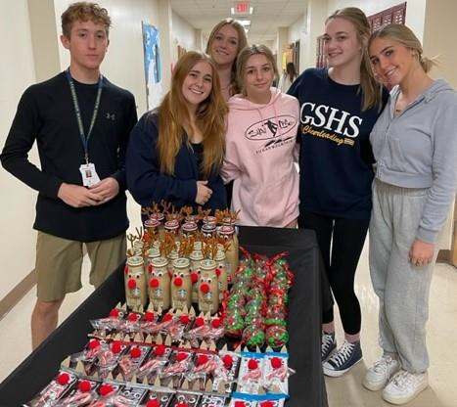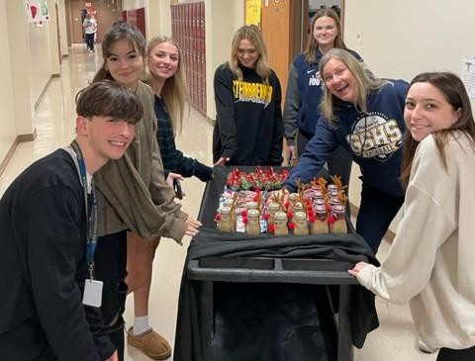

Senate delivering holiday treats to the teachers and staff.

