STEINBRENNER PTSA NEWSLETTER
APRIL 2023
VOLUME 10
ISSUE 7

George Steinbrenner High School 5575 W. Lutz Lake Fern Rd.
Lutz, Florida 33558
813.792.5131
A Hillsborough County School

Visit our website: steinbrennerptsa.com

PRESIDENT’S NOTE
Hello Warrior Families!
It is hard to believe that we are entering our last term for this school year. The PTSA is busier than ever! We are working with the administration on planning senior awards and senior events, planning a special teacher appreciation week, coordinating senior banners and yard signs, and working on various school improvement projects. In addition, we are preparing for the annual parking space auction (pg. 4)!
Our elections for Board positions for next year will take place at our meeting on May 3rd. We are continually looking for new members to join our board. If you have ever considered participating, please reach out to me at gshsptsapresident@gmail.com. Ms. Ewell and the entire Steinbrenner administration have been very generous with their time and support that they provide to our PTSA. By participating on the PTSA board, you are provided a forum to ask questions, provide suggestions, and obtain clarification at our monthly board meetings. We have an amazing group of individuals taking on various roles, which allows the workload to be spread out, making all positions manageable. We welcome any level of commitment you can provide.
We have volunteer opportunities in April and May. See page 2 for information on how to volunteer for Senior Banners and other Senior events. See page 3 for ways to help our Teacher Appreciation Week committee. Students can earn Bright Futures or PTSA Senior Scholarship 2024 volunteer hours when helping with PTSA initiatives.
On behalf of Steinbrenner PTSA, I wish everyone a great final quarter of the school year.

Go Warriors Alison Newman
GSHS PTSA President 2022-2023
gshsptsapresident@gmail.com

April:
7 No School
Calendar
13 Senior Honors Graduate Banquet (morning)
13 Senior Awards: Invite Only- Student and Family Event (evening)
21 Grad Bash
24 2:30pm; Hang Senior Banners (pg. 2)

May:
1 Deadline to order Senior Yard Sign (pg. 2)
1 AP Testing begins
1-5 Teacher and Staff Appreciation Week (pg. 3)
3 General PTSA Meeting; time & location TBA
8-12 Parking Space Auction (pg. 4)
14 9:00am; Graduation Rehearsal
15 2:30pm; Take down Senior Banners (pg. 2)
17 Last Day for Seniors
18 Senior Send Off
22-26 Final Exam Week (schedule TBA)
25 12:00pm; Graduation Ceremony (invite only)
26 Last Day of School (early dismissal)
*Dates and times are subject to change
PTSA Calendar 1
Steinbrenner HS Calendar
District Calendar

2022-2023 Board Members

SENIOR YARD SIGNS ONLY $15
Deadline to order: May 1st

Do not miss out! Order your senior yard sign today! CLICK HERE
to purchase.
Yard signs and senior banners will be distributed to students at Senior Send Off on May 18th.
President: Alison Newman
Treasurer: Natasha Sherwood 1st VP Membership: Tamara Ponce
2nd VP Strategic Planning: Hanna Curry 3rd VP Fundraising: Shelly Saunders
4th VP Volunteers: Venessa Daughtrey Recording/Corresponding Secretary:
Shadia Aouadi
ACT/SAT Prep and College Readiness Programs: Maurine Wheeler
VOLUNTEERS NEEDED: SENIOR BANNERS
Senior Banner Hanging
April 24
Senior Banner Take Down
May 15
Both start at 2:30pm
Meet in Steinbrenner Cafeteria
We need both parent and student volunteers to hang up and take down senior banners.
JUNIORS: Volunteer hours earned for hanging and taking down banners will apply to the PTSA Scholarship 2024.
PARENTS: We need 10-foot ladders. The ladders will be returned to the owners at the conclusion of each event.
If you can help in any way, please contact
gshsptsaseniorbanners@gmail.com.
Hospitality: Laurie Grantham PE/Hope Uniforms and Spirit Wear:
Portia Engman
Senior Banners: Natali Lima Senior Events: Marty Sheehan
Lisa Aiken Steinbrenner Cares: Erica Rude
Teacher Appreciation Week:
Melissa Siebels Monica Young
Teacher Grants and School Improvements: Jennifer Harbour
Website and Social Media:
Michelle St. John Dawn Hoskins
CLASS OF 2024
PTSA Senior Scholarship Volunteer Opportunities
Save the dates! More information will be posted on social media.
April 12: Senior Honors Graduate Banquet setup (evening, time TBA)
April 13: Senior Awards-invite only, Student and Family Event (evening, time TBA)
May 18: Senior Send Off (time TBA)
Email to sign up: gshsptsavolunteers@gmail.com
Parents and Students: There are additional volunteer opportunities. For more information and how to sign up, see Senior Banners (pg. 2, above) and Teacher Appreciation Week (pg. 3).
PARENT VOLUNTEERS:
If you have not filled out the district’s volunteer application, do so by CLICKING HERE. All volunteers are required to have an approved application on file.
World of a Teen: Francine Phillips
Jennifer Labadie-Waldhauser
Awards: Cheryl Michel
Newsletter: Leslie Nixon
Reflections: Melissa Siebels School of Excellence: Amy Pardo Senior Scholarships: Kristen Miller
Bethany Mis Faculty Representative: Heather Prokop Member at Large: Jonilyn Maglott
Monica Young
Principal: Tiffany Ewell

STAY IN THE KNOW
Steinbrenner PTSA
Website:
www.steinbrennerptsa.org
The PTSA website can be translated into a variety of languages. Scroll to the bottom of the home page and click on “Select Language.” From there, choose your preferred language.
Steinbrenner
PTSA
online
store:
https://gshsptsa.memberhub.store/
PTSA Newsletter: The Steinbrenner PTSA newsletter will be sent monthly to all registered families. shsptsanews@gmail.com
Steinbrenner PTSA Facebook: Join the Steinbrenner PTSA Facebook page for the latest school news. https://www.facebook.com/steinbrennerptsa/
PTSA
https://twitter.com/SteinbrennerPTA
Twitter:
School News: Steinbrenner High School website
http://steinbrenner.mysdhc.org/
District News: Hillsborough County School District Website https://www.hillsboroughschools.org
Hillsborough County PTA
Florida PTA
National PTA
Canvas
Steinbrenner PTSA Needs YOU

BOARD AND COMMITTEE VOLUNTEERS NEEDED
2023-2024
Our PTSA is looking for volunteers to fill vacancies for the 2023-2024 school year. It is fun and a great way to stay connected to all that is happening at Steinbrenner.
If you are interested or have questions, please contact
gshsptsapresident@gmail.com.
JOIN US! TEACHER APPRECIATION WEEK EVENT #2

YOU ARE INVITED!
Mark your calendar for an exclusive event you do not want to miss.
April 22 10:00am-9:00pm
Give a gift of appreciation to the Steinbrenner teachers by purchasing a ZIP ID case or Lanyard. Only
$5 each. Your purchase will be donated to the Steinbrenner teachers during Teacher Appreciation Week.
For more information, call 813-909-0576.
Exclusions and limitations may apply. See a store associate for details.
Teacher Appreciation Week May 1-5
Help us honor our Steinbrenner teachers and staff for the amazing job they do. We have two easy ways to donate:
- CLICK HERE for our SignUpGenius list of needed items
- CLICK HERE to make a monetary donation
Email gshsptsastaffappreciation@gmail.com if you are a business or family who would like to sponsor a meal during Teacher Appreciation Week.
THANK YOU FOR YOUR DONATIONS BUSINESS PARTNERS
Aussie Grill Vera Bradley Chick-Fil-A Top Golf Winn Dixie Chuy’s
BJ’s Brewhouse
Kendra Scott
Sacred Pepper Rock and Brew
Outback Steakhouse
JOIN US! TEACHER APPRECIATION WEEK EVENT #1
Kendra Scott Boutique 1511 Swann Ave, Tampa FL April 7
Noon-2:00pm
Drinks and sweets provided
Can’t make it to the store? SHOP ONLINE April 7 and 8. Giveback code: GIVEBACK-DTSGL
20% of all Kendra Gives Back revenue will be donated to Steinbrenner PTSA.

Steinbrenner PTSA Wants to Hear from YOU
Steinbrenner PTSA is looking for input from our GSHS teachers, parents, and students for new ideas to make our PTSA more meaningful to our Warrior Community. If you have an idea for a new program or something you would like to see from the PTSA, we would love to hear it!
Please
email
Hanna
Curry
at
gshsptsastrategicplanning@gmail.com with subject
line “New Idea.”

Chorus Concert
Horizon’s: Out of this World
May 5th and 6th 6:00pm
Steinbrenner Auditorium
Buy a ticket from any chorus student for $5 each. Tickets will be $7 at the door.
Do not miss the biggest concert of the year. Costumes, decorations, and songs have been selected by and will be performed by all members of the Steinbrenner Chorus Program.
Flowers, concessions, and Space-grams (notes of encouragement to a performer) will be available for purchase! More information will be posted to social media soon.

Steinbrenner Orchestra Concert
Friday, April 28 6:00-9:00pm
Steinbrenner Auditorium
Tickets sold at the door Cash: $5.00 per person Credit: $5.50 per person
Children under 5 years old and Steinbrenner Faculty are free.
Everyone is welcome!

Save the Date!
Annual Parking Space Auction May 8-12
Bidding for the PTSA annual parking space auction for rising Juniors will start at 8:00am on May 8th. The fundraiser will auction one parking space per day for 5 days!
Proceeds from the auction will benefit PTSA scholarships for 2024 graduating Steinbrenner Seniors. Due to the continued success of the annual auction, the PTA has awarded over $12,000 in scholarships annually for the past 6 years!
More information and a link to the auction will be posted on the PTSA WEBSITE and social media as the date approaches.
Want Volunteer Hours Toward the Bright Futures Scholarship?
Submit an article and at least one picture to the PTSA Newsletter and start earning required volunteer hours toward the Bright Futures Scholarship.
- Article can be about anything school/education related or a topic that is important to you and others your age.
- Must include at least one picture. Student is not required to be in the picture.
Deadline to submit an article for the next newsletter is April 26. Submitted articles must be well written, are subject to editing, and will be forwarded to Ms. Ewell for approval prior to publishing.
Submit your article, picture(s), and/or questions to Leslie Nixon at shsptsanews@gmail.com.
Juniors: You can earn volunteer hours toward the Senior Scholarship 2024 by submitting a newsletter article now.

Auditions – Chamber Orchestra
Tuesday, April 18 4:00-8:00pm
Questions? Email andrea.szarowicz@hcps.net.

STEINBRENNER SPIRIT WEAR

Mascot Universe is the place to go for all your spirit wear needs! Their location, in the Publix plaza next to Rice and Roll, has lots of space for all the Steinbrenner spirit wear. Shop there for several of our new designs.
Mascot Universe donates back to our PTSA for every Steinbrenner item purchased.
Cannot make it to the store? CLICK HERE to place an order.
BECOME A STEINBRENNER PTSA BUSINESS PARTNER
We are currently looking for businesses in our community and corporate sponsors to help our school succeed this school year. With your partnership, we will be able to continue offering support to our students and teachers.

- Donations of funds, products, and/or services are tax deductible.
- Business Partners will be featured on the PTSA website and in our newsletter that is
published to
families.
over
2000 Steinbrenner
If your business would like to partner with
Steinbrenner PTSA and help us provide additional opportunities for our students, teachers, and staff, please contact us at gshsptsasponsors@gmail.com.
THANK YOU! YOUR DONATION SUPPORTS OUR PTSA AND SCHOOL COMMUNITY.
My Fitness Answer is a private fitness training studio located in Lutz.
They take your health and fitness goals seriously by creating a personalized fitness and nutrition plan for you. Their goal is to change your view on fitness and health.
https://myfitnessanswer.com/
information.
CLICK HERE for client reviews.
for
more
»»Specializing in Sport Performance and Senior Fitness
»»Private training studio and packages

THANK YOU FOR YOUR DONATION
SUPPORT THE BUSINESSES THAT SUPPORT OUR PTSA & SCHOOL COMMUNITY.
An appointment is not needed, but feel free to check out their website www.lutzuc.com and fill out the patient registration form to speed up the process.
Most major insurances accepted.

THANK YOU FOR YOUR DONATION
#1 community bank in Florida and top 100 nationwide by American Banker.
Invest in your community when you open a checking account with First Citrus Bank.
Visit their website www.firstcitrus.com for more information. First Citrus Bank can help you with all your personal and business banking needs.

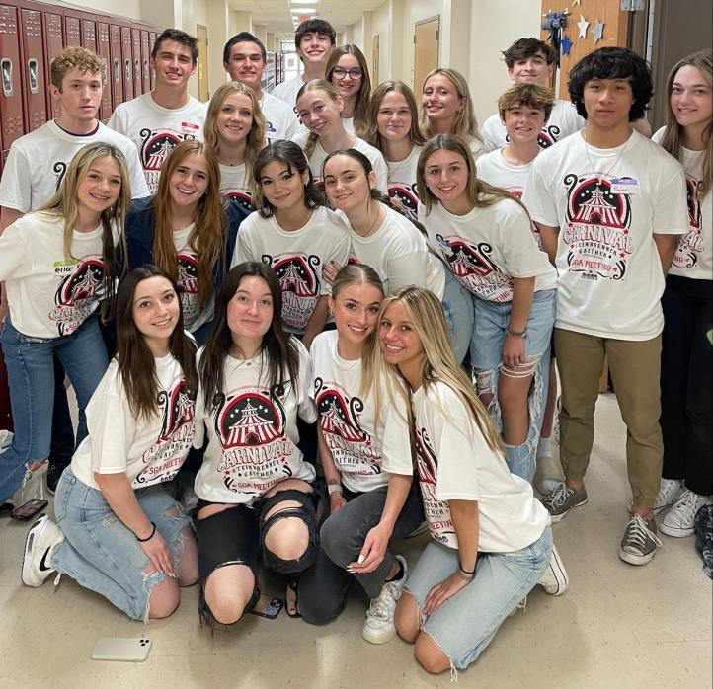
Senate
Senate hosted 26 high schools for a county wide student government meeting.
It is Not Too Late!
Become a PTSA Member Today
JOIN ONLINE BY CLICKING HERE.
Questions: Email gshsptsamembership@gmail.com
Save money! Businesses offer discounts to PTSA members. CLICK HERE to see how you can take advantage.

Florida PTA is celebrating 100 Years of Advocacy for Children
Join Florida PTA to commemorate the past century of progress. They have worked tirelessly to make every child’s potential a reality by engaging and empowering families and communities to advocate for all children, across the state and the country alike.
For more information CLICK HERE
To register, CLICK HERE
Care For Kids: Basket Donations Needed
Care for Kids is collecting items such as candy, coloring books, crayons, small puzzles, or fidget items to create care packages for kids who are going through hard times.
If you can donate, please drop off items to ROOM 351. No donation is too small. Everything helps.
CONGRATULATIONS STEINBRENNER JROTC
Steinbrenner JROTC teams became Robotic State Champions for the second year in a row.
They won:
- Excellence Award
- Tournament Champions
- Skills Champions
- Think Award
The teams will be going to the national competition in Dallas, TX to compete against 160 JROTC teams from around the country.
Orchestra
Do you have a student who is interested in joining Steinbrenner Orchestra next year? Steinbrenner Orchestra has three different levels of ensembles:
- Concert Orchestra - Freshman that completed middle school orchestra and first year players.
- Symphonic Orchestra - Sophomores, Juniors, and Seniors.
- Chamber Orchestra - Students who audition on April 18, 2023. (See audition information on pg. 4.)
If your middle school student is enrolling at Steinbrenner for the 2023-2024 school year and you have questions about placement, email andrea.szarowicz@hcps.net. Orchestra has many opportunities for all students.

Florida PTA

Florida PTA’s Committee Interest Survey is now open year-round for volunteer applications. As the needs of Florida PTA change, so does the availability of potential volunteer opportunities. CLICK HERE to apply.

To help create a healthy earth, we all must play our part. CLICK HERE to learn more about what your family can do to form healthy habits related to preventing waste and conserving energy. Save the date to celebrate Earth Day with our 2023 National PTA Day of Service.

A Podcast for Parents, by Parents
PTA is working to ensure our public schools provide a high-quality education for every child to reach their full potential. Notes from the Backpack is a PTA podcast designed for millions of parents and the decisionmakers they influence.
Through the unique combination of expert, parent, and educator guests, each episode features engaging conversations that offer real life advice and ideas on how to support children’s learning and development.
Real Experts. Real Parents.
Real Conversations.

Did you know that families who are more engaged in a school have students that are more engaged and have a higher school success rate? Students with involved parents are more likely to earn higher grades and pass their classes, attend school regularly, have better social skills, and go on to post-secondary education.
CLICK HERE for more information.
HCC PTA
General Meeting April 13 6:00pm Via Zoom
RSVP required: CLICK HERE

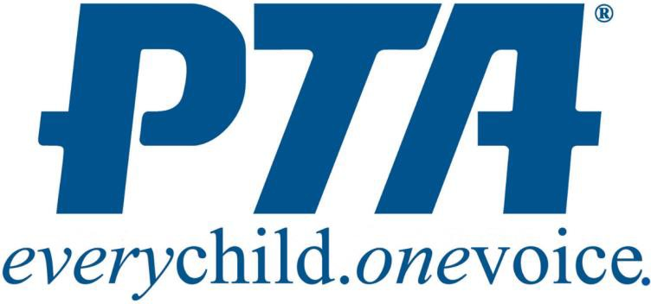

Transforming Family-School Partnerships with PTA’s National Standards Webinar Series
National PTA’s Center for Family Engagement is partnering with the Institute for Educational Leadership for a five-part webinar series. The goal is to help district, school, and parent/community leaders explore our six National Standards for Family-School Partnerships through panel discussions with leading practitioners, researchers, and policy makers. Our hope is to improve family-school partnerships so that all children can reach their full potential.
The final webinar, Webinar 5: Collaborate with Community, starts at 2:00pm on April 19. Register at https://bit.ly/3k9gpF6
Find Webinars 1-4 on National PTA’s YouTube channel:
https://www.youtube.com/@nationalpta

National PTA is excited to collaborate with Norton to empower families to make smarter, safer decisions online. A newly updated Smart Talk tool has been launched: TheSmartTalk.org. This tool increases the depth and success of your digital safety conversation with your child.

June 15-24
Registration for the 2023 National PTA Virtual Annual Convention is now open!
Join the National PTA and connect with PTA leaders, educators, and parents to reinforce the mission, outreach, and impact in our school communities to make a difference for every child.
CLICK HERE to register.

STUDENT SERVICES UPDATES
Scholarship Opportunity Costal Jaw Surgery Scholarship Deadline: April 21, 2023
For Seniors who plan to pursue a career in the healthcare field.
More information and the application are on Canvas under the Guidance Services “Scholarship Bulletin” tab.

STUDENT SERVICES UPDATES CONTINUED…
Profferfish/Volunteer Hours
With the end of the year just around the corner, students are encouraged to continue working on volunteer hours. Hours should be submitted through Profferfish at the conclusion of each volunteering event, not months or even years later.
What is a complete Profferfish submission?
- Profferfish form is filled out in its entirety
- Has event coordinator or representative signature
- Has parent or guardian signature
Seniors, check your canvas email.
A message was sent to all seniors that have incomplete submissions in Profferfish. These submissions are missing one or more signatures.
All students should check their Profferfish account regularly for incomplete submission notifications. It is the student’s responsibility to ensure that submissions are complete. Hours submitted will not be reflected on a student’s account if the submission is incomplete.
May 1, 2023 - Deadline for Seniors to submit COMPLETED volunteer hours.
Exploring Post-Secondary Options: College, Technical School, Military, Workforce
This is a great time for Juniors to start exploring their post-secondary options. Every student is different; therefore, their paths will be different.
Sign up for a campus tour.
Colleges and technical schools welcome students to tour their campus, speak with admissions counselors, and more. Most schools will require you to sign up for a tour; however, some have a self-guided tour app or an online map with written guide. Check the college or technical school’s website to sign up for a tour.
If your student is considering technical college, it is important they visit different schools. Not all technical colleges offer the same programs and one can be very different from the next.
Military
Students considering the military are encouraged to speak to recruiters from each branch. Since each has different requirements, these conversations will help your student decide with branch is best for them. A list of recruiters can be found under Guidance Service’s “Careers” tab on canvas.
AP Testing
May 1 - AP testing begins
The AP exam schedule is posted on College Board’s website. If your student has any questions about testing, they should be communicating with their teachers now. This will help eliminate issues on the day of testing.
Morning AP Exam
Students should report to their testing locations no later than 7:30am. Afternoon AP Exam
Students should report to their testing locations no later than 11:30am. Information on testing locations will be posted soon.
Transportation:
Since AP testing starts before the school day begins and some testing will continue beyond the normal school day, students need to make arrangements for transportation. College Board has very strict policies and students are not allowed to arrive late or leave early from testing.

STUDENT SERVICES UPDATES CONTINUED…
Seniors
It is very important for seniors to continue being involved in their classes. While GPA and rank have already been determined, second semester grades can impact post-secondary aspirations. Universities can rescind their acceptance due to declining grades. It has happened and it is not worth the risk.
Survey: Important Information Needed
We will send a survey link in May requesting information from seniors including but not limited to:
- Scholarships names and amounts awarded
- Post secondary plans such as college, technical or trade school, or military branch
- School address
This survey ensures that we provide your student’s final transcript to the college they are going to attend. A final transcript is proof of graduation. Without it, your student will not be able to register for classes or receive financial aid.
Final transcripts will be sent out over the summer. If your student changes plans after completing the survey, they should call the school to update our registrar or data processor.
Financial Aid Applications
All Seniors should have completed the FFAA for Bright Futures and other state scholarships and the FAFSA. These applications should be completed even if they have not met Bright Futures requirements or do not think they qualify for financial aid.
Important Dates
April 4 – All 10th graders will take the state BEST Writing Test
April 12 – During school day; “Non-Reportable” SAT for Seniors who need to meet a graduation benchmark
April 13 (A.M.) – Senior Honors Graduate Banquet (invitation only; for Seniors earning a weighted 4.0 GPA or higher)
April 13 (P.M.) – Senior Awards Ceremony (invitation only; Seniors and Family)
May 1 – All volunteer and paid work hours must be submitted for approval (Seniors only) May 1 – AP Testing begins
May 12 – Deadline for Seniors to complete HVS/FLVS classes May 14 – 9:00am; Graduation Rehearsal
May 19 – Senior Final Exams begin
May 25 – 12:00pm; Graduation Ceremony
March was Women’s History Month: Here is My Inspiration
By Tabitha Ponce
Hedy Lamarr was a well-known actress, but she also had a gift for inventing. She spent a lot of time behind cameras, and was in many movies, films, and more. It was toward the end of her life when her technological discoveries were made known.
In 1940, she met the composer George Antheil at a party, where they talked about radio controlled objects. She came up with the idea of changing frequencies at random intervals between the transmitter and receiver. They used piano rolls to synchronize the signals. That is also why the number of keys on a piano matches the number of frequencies; 88. The two were granted a patent in 1942.
Hedy’s invention is used in our smart phones with Bluetooth low energy devices. She is the inventor of frequency- hoping spread spectrum (FHSS), that is involved in Wi-fi, Bluetooth, wireless internet, communication, and more.
A NOTE FROM OUR STUDENTS

